Colon Cancer

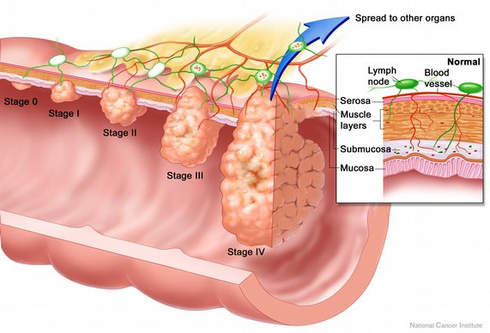

Stages of colorectal cancer.NCI, NIH

MSI

MSS

CIMP

LINE-1

MLH1(mismatch repair gene) hypermethylation caused low expression of MLH1 and then MSI happened.